1 Model ***A*** and ***B*** units have a 26 pin GPIO along the edge of the board near the yellow video out socket

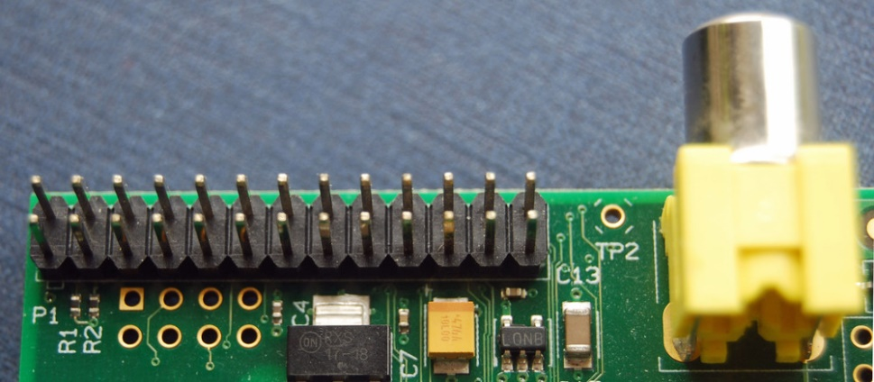

Pin 1 is marked on the circuit board as P1

2 The pin outs are usually represented in two ways. Firstly they can be shown as physical pins

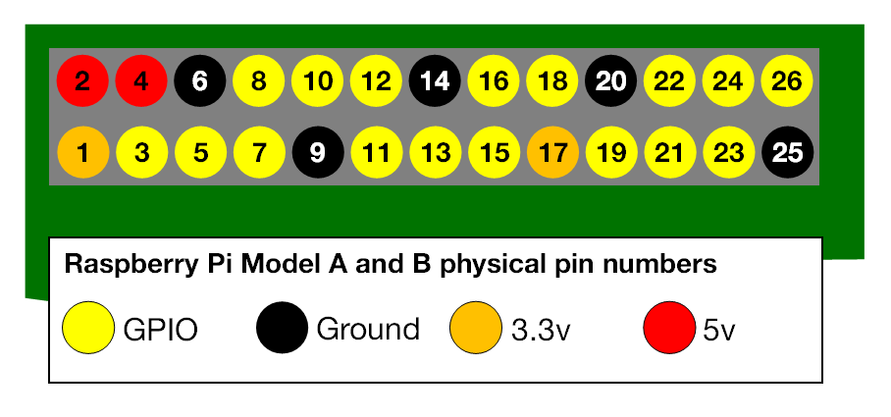

This is how ScratchGPIO7 programs usually refer to the pins



3 More usually the pins are represented by their ***GPIO*** number

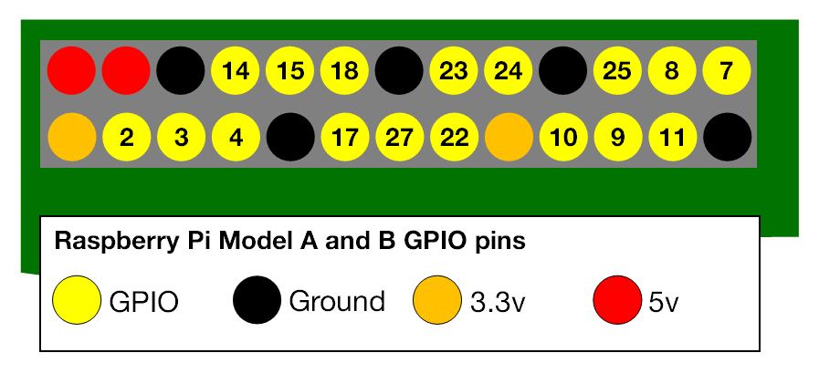

GPIO stands for **General Purpose Input/Output**

*Seventeen of the 26 pins are GPIO pins, the others are power or ground pins*

4 Or if you are building a ***circuit*** using your Raspberry Pi then you may want to know the pin’s actual function.

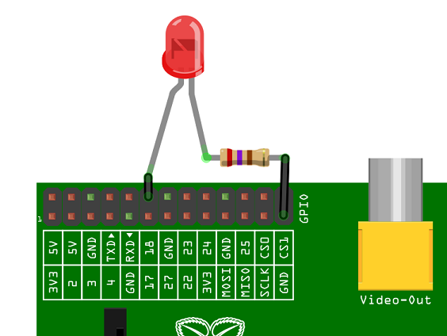

Need more help? Go to <https://www.raspberrypi.org/>